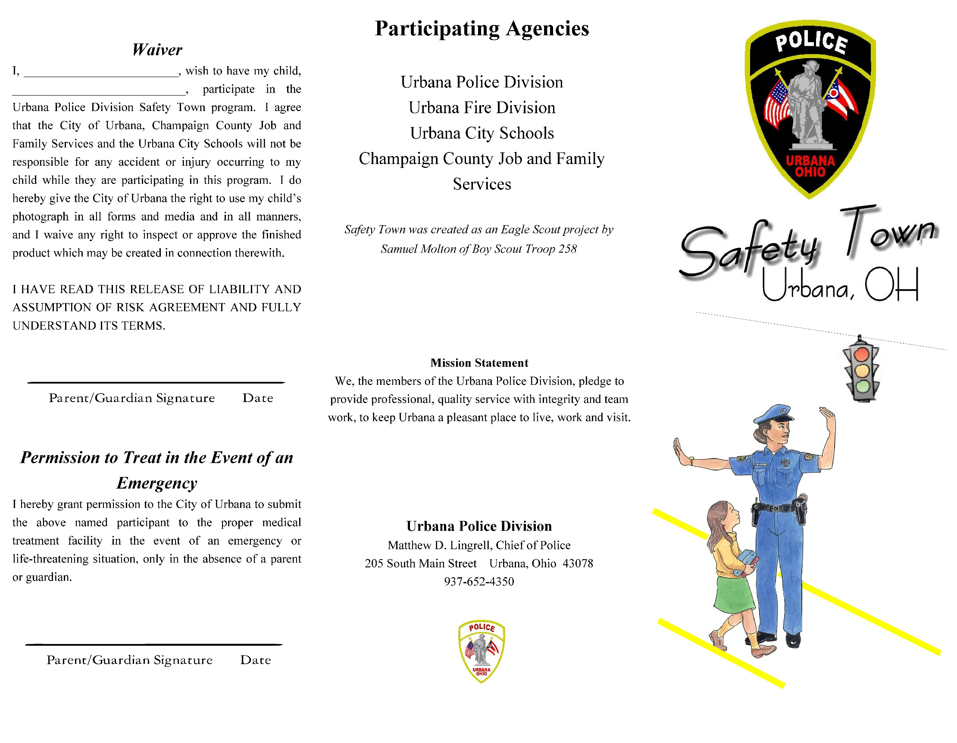

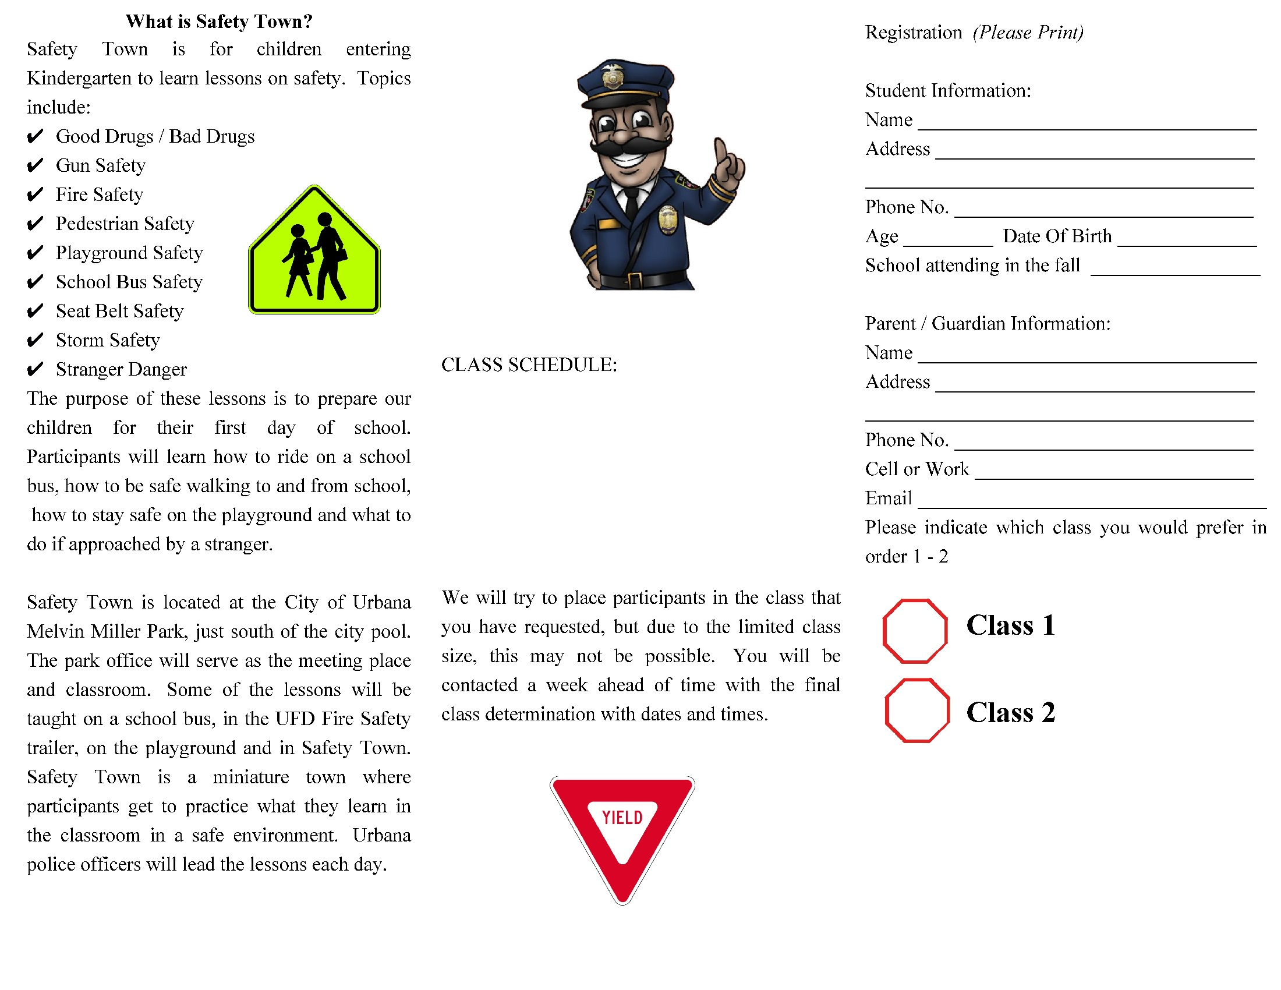

**Class 1: June 19th – 23rd, 2023**

**8:30 a.m. – 11:00 a.m.**

**Class 2: June 26th – 30th, 2023**

**8:30 a.m. - 11:00 a.m.**

*\*\*\*Information will be distributed through email\*\*\**